**MST 1102- Introduction to Statistics WkSheet 3**

**(Last Name, First Name): ______________________________________________________________**

**Data Presentation I**

1. A random sample of size $n=5$ is to be selected from a population of $N=14$. The $14$ members of the population are numbered as shown below:
2. Alana
3. Anthonio
4. Aqib
5. Bibi
6. Chandradatt
7. Christa
8. Esther
9. Ikey
10. Jennifer
11. Nitesh
12. Sydney
13. Trevor
14. Tyrese
15. Varsha

Use the portion of the table of random numbers shown below to determine which 5 members from above should be in the sample. [Start from the second row] **[5 marks]**

1. Briefly explain why we need to group data in the form of a frequency table. **[2 marks]**

______________________________________________________________________________________________________________________________________________________________________________________________________________________________________________________________________________

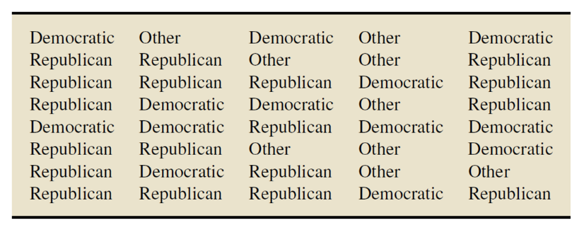

1. Professor Weiss asked his introductory statistics students to state their political party affiliations as Democratic (D), Republican (R), or Other (O). The responses of the 40 students in the class are given in the table on the right. Determine a frequency, relative frequency and percentage distributions of these data. **[5 marks]**

|  |  |  |  |  |
| --- | --- | --- | --- | --- |
|  |  |  |  |  |
|  |  |  |  |  |
|  |  |  |  |  |
|  |  |  |  |  |
|  |  |  |  |  |

1. Draw a bargraph to represent the data in the table above. **Put relative frequency on the y-axis.** **[3 marks]**
2. When would it be more appropriate to use relative frequency when drawing a bargraph as opposed to using frequency? **[2 marks]**

_____________________________________________________________________________________________________________________________________________________________________________________________________________________________________________________________________________________________________________________________________________________________________________________________________________________

1. 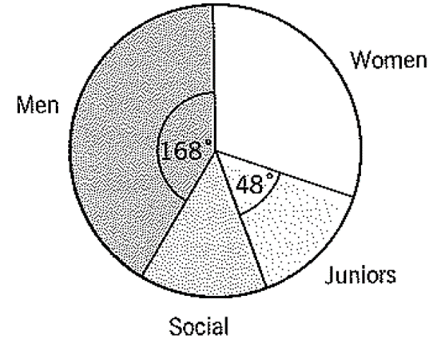A golf club has four categories of membership: men, women, juniors and social members. The pie chart shown, which is not drawn to scale, illustrates the distribution of membership in 1995. Given that there were 147 men and 35 social members, calculate:
2. The number of junior members. **[2 marks]**
3. The angle of the sector representing social members. **[2 marks]**
4. The number of women. **[2 marks]**

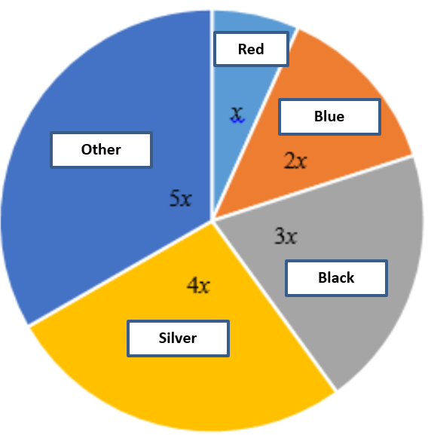

1. The pie chart shows the proportion of cars in different colours.
2. Determine the size of each angle. **[2 marks]**
3. Tyra says that the survey included 200 cars. Explain how you know that Tyra is wrong. **[2 marks]**

____________________________________________________________________________________________________________________________________________________________________________________________________________________________________________________________

1. If there were between 200 and 250 cars in the survey, how many cars could be in the survey? **[2 marks]**

**____________________________________________________________________________________________________________________________________________________________________________________________________________________________________________________________**

1. 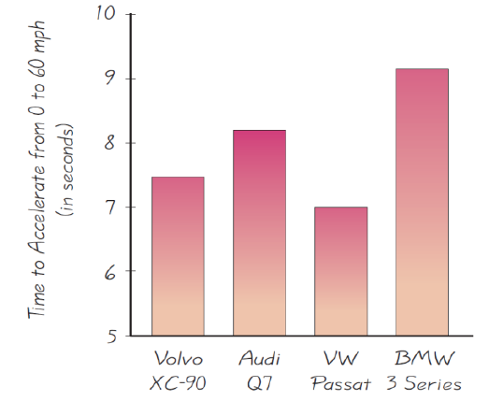The accompanying graph to the right illustrates the acceleration times (in seconds) of four different cars. The actual acceleration times are as follows: Volvo XC-90: 7.6 s; Audi Q7: 8.2 s; Volkswagon Passat: 7.0 s; BMW 3 Series: 9.2 s. Does the graph correctly illustrate the acceleration times, or is it somehow misleading? Explain. **[2 marks]**

_____________________________________________________________________________ _____________________________________________________________________________ ____________________________________________________________________________ ____________________________________________________________________________

1. 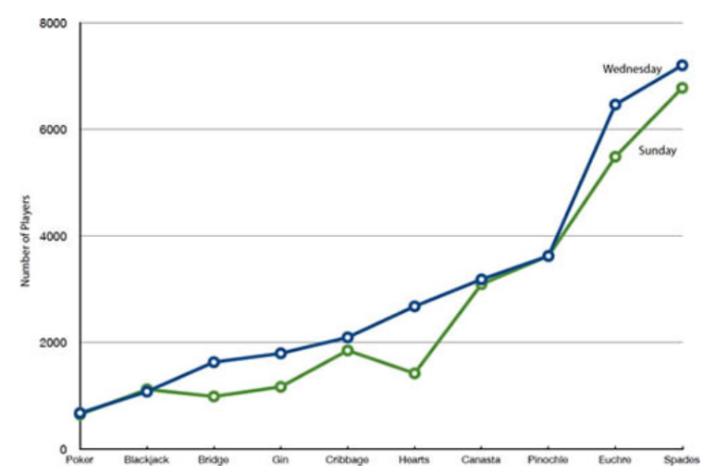The line graph depicts the number of people playing different card games on Sunday and Wednesday. Lonette claimed that the number of persons seems to be increasing over the various card games. Comment on the appropriateness of the use of the line graph and on Lonette’s claim. **[3 marks]**

**________________________________________________________________________**

________________________________________________________________________

________________________________________________________________________

________________________________________________________________________

________________________________________________________________________

________________________________________________________________________

**Total: 32 marks**